**ANSWER SHEET**

**PART 1**



**PART 2**



**PART 3.**



**PART 4**



**QUESTIONS**

**PART 1. MATCH THE WORDS WITH THE PARTS OF THE CHEQUE**

|  |  |  |
| --- | --- | --- |
| account number | amount in figures | amount in words |
| logo | payee | signature |

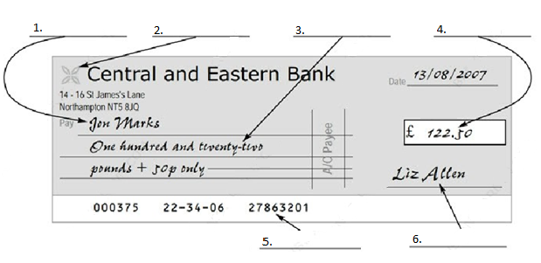

**PART 2. CHOOSE THE CORRECT WORDS**

**EPOS AND EFTPOS**

EPOS (electronic point of sale) terminals are cash ***1*** *registers/machines* found in ***2*** *selling/retail* outlets such as shops and restaurants. Data about each sale is ***3*** *entered / put* via barcode scanners, keyboards or ***4*** *touch/finger* screens. The data is used to provide an itemised ***5*** *receipt/ticket* for the customer. It can also be used for stock control and to help with marketing.

EFTPOS (electronic funds transfer point of sale) terminals are similar to EPOS terminals, but they can also ***6*** *understand/read* credit and debit cards, and ***7*** *transfer/transmit* funds directly from the customer’s account to the retailer’s account.

When customers pay ***8*** *by/with* card at an EFTPOS terminal, they either ***9*** *sign/signature* a sales voucher, or enter a PIN (Personal ***10*** *identifying/identification* number). Obviously, a PIN is a more ***11*** *secure/safe* method of verification than a ***12*** *signing/signature*, and in many countries, all EFTPOS ***13*** *transactions/sellings* are now ***14*** *checked/verified* by PIN

**PART 3. READING COMPREHENSION**

**THE SUBPRIME CRISIS AND THE CREDIT CRUNCH**

**Deregulation in the 1980s was one of the factors that led to the subprime crisis.**

When American house prices began to fall in 2007, many ‘subprime’ borrowers, defined as those with poor credit ratings and consequently a high risk of default, stopped paying their mortgages, as their debt was greater than the value of their house. Unfortunately, the institutions which had issued the mortgages had created financial products called mortgage-backed securities (MBS) and collateralized debt obligations (CDO), which had been bought by many financial institutions including investment banks, hedge funds, insurance companies, pension funds, mutual funds, and so on. This process is called securitization: financial assets like mortgaged which produce a cash flow are pooled (grouped together) and converted into securities that are then sold to investors.

MBSs and CDOs give their buyers the right to receive the payments on the underlying mortgages, and banks bought them because they believed that house prices would continue to rise, and households would continue to make their mortgage payments. But when many subprime borrowers stopped paying, the value of subprime related securities fell dramatically. Many banks in the USA, Britain and elsewhere lost billions of dollars on their MBSs; some went bankrupt, and others had to be rescued by governments. It is estimated that banks around the world will eventually have to write off $1.5 trillion of worthless subprime MBSs (now often referred to as ‘toxic debt’). These losses destroyed much of the capital of the world banking system, leading to a credit crisis or a ‘credit crunch’: a massive reduction in the amount of credit available for banks to lend to other banks, businesses and household.

**A. Find the words or expressions in the text above which mean the following.**

1. Estimates of people’s ability to fulfill their financial commitments.
2. A failure to fulfill an obligation, especially to repay a loan.
3. An amount of money borrowed by one party from another.
4. A loan, usually to buy property, which serves as a security for the loan.
5. An establishment that focuses on dealing with financial transactions, such as investments, loans and deposits.
6. A sum of money reserved to pay a company’s retired
7. A company that spreads investors’ capital over a variety of securities.
8. A financing or investment instrument issued by company or government agency that denotes an ownership interest and provides evidence of a debt, a right to share in the earnings of the issuer, or a right in the distribution of a property.
9. A person who allocates capital with the expectation of a future financial return
10. Unable to pay debts or continue to do business.

**B. According to the text above, are the following statements true or false?**

1. ‘Subprime’ borrowers are considered as those with high credit ratings. TRUE/FALSE
2. The value of subprime related securities rocketed dramatically as many ‘subprime’ borrowers stopped paying TRUE/FALSE
3. Many banks were saved by government from bankruptcy. TRUE/FALSE
4. The capital of the world banking system was destroyed dramatically. TRUE/FALSE

**PART 4. READING COMPREHENSION**

**A. Match the words from the account summary below with the definitions**



|  |  |
| --- | --- |
| 1. audited | 1. reduction in value of an asset over time |
| 1. revenue | 1. money paid to shareholders |
| 1. turnover | 1. asset purchased for long-term use, such as land, buildings etc. |
| 1. fixed asset | 1. after any deductions |
| 1. depreciation | 1. account checked by an independent examiner |
| 1. net | 1. a person who has invested in the company through buying shares |
| 1. shareholder | 1. gross income |
| 1. dividend | 1. total income |

**B. Look at the account summary and answer TRUE or FALSE**

1. Turnover is income after outgoings have been deducted. TRUE/FALSE
2. Salaries and wages were the only major operating cost. TRUE/FALSE
3. Depreciation of fixed assets seriously reduced operating profits. TRUE/FALSE
4. Parker Publishing spent a lot on sales and marketing. TRUE/FALSE
5. The company sold some assets. TRUE/FALSE
6. Nearly all the profits went to the shareholders. TRUE/FALSE
7. Dividends were only 17.4p per shareholder. TRUE/FALSE
8. It was a very bad year for Parker Publishing. TRUE/FALSE

** END OF THE TEST **

**ANSWER SHEET**

**PART 1**



**PART 2**



**PART 3.**



**PART 4**



**QUESTIONS**

**PART 1. MATCH THE WORDS WITH THE PARTS OF THE CHEQUE**

|  |  |  |
| --- | --- | --- |
| account number | amount in figures | amount in words |
| logo | payee | signature |



**PART 2. CHOOSE THE CORRECT WORDS**

OPEN AN ACCOUNT TODAY

Open an account with Grimleys Bank, and start benefiting our great **1** *rates/levels* of interest and **2** *small/low* charges. With over 3,000 **3** *branches/outlets*, you’ll never be far from us, and unlike many other **4** *high street/town centre* banks, we’re open all day on Saturday.

Grimleys customers can **5** *take money/make withdrawals* from more than a million **6** *cash dispensers/ money machines* worldwide, and of course you’ll receive a **7** *cheque book/book of cheques* and a 8 *paying card/debit card* within a few days of opening your account.

Computers users may be interested in our e-account – all the benefits of a regular Grimleys’s **9** *current/day-to-day* account, with the added convenience of being able to view your **10** *lists/statements* and **11** *make/do* payments online.

Whether you’re opening your first current account, **12** *switching/changing* from another bank or simply want to take advantage of our **13** *range/variety* of saving accounts, you’ll be glad you chose Grimleys – the bank that always **14** *makes/puts* the customer first.

**PART 3. READING COMPREHENSION**

**Bank of England raises interest rate to 5%**

Mortgage repayments, along with the cost of overdrafts and credit card debts, are set to rise after the Bank of England surprised the City yesterday by announcing its first rise in interest rates for more than a year.

News of the quarter-point rise to 5% was cautiously welcomed by some financial institutions, but was largely condemned by industry and trades unions.

A statement from the Bank of England’s monetary policy committee said that strong growth, a recent recovery in consumer spending, buoyant export market and signs of a pick-up in investments meant that an action was necessary in order to meet the government's 2.5% inflation target.

The statement said: “With inflation likely to remain above target for some while, it was judged necessary to bring consumer prices inflation back to target in the medium term.”

A response from the London Board of Businesses and Exporters described the move as premature and likely to damage businesses, especially those dependent on export earnings.

Many homeowners will face higher monthly bills through increased mortgage costs, especially those with variable rate and base-rate tracker mortgages. If mortgage lenders pass on the rise in full, it will add around £20 to the monthly repayments on a £100,000 mortgage. According to Sarah Parker of the Family Income Monitoring Unit, the average family will need to find around another £40 a month.

Few analysts predicted a rate increase, and some had even been expecting a decrease to help boost a subdued housing market. Many were talking about the increase being a pre-emptive strike, with the small increase in borrowing costs now intended to ward off the need for a more painful rise later.

In the City’s money markets, however, there were expectations of a further tightening of the Bank’s policy and further interest rate increases would affect consumer spending wiped £17bn off the value of the London stock market.

**A. Find the words or expressions in the text above which mean the following.**

1. an extension of credit from a lending institution when an account reaches zero.
2. the amount charged, expressed as a percentage of principal, by a lender to a borrower for the use of assets.
3. the establishments that focuses on dealing with financial transactions, such as investments, loans and deposits.
4. a general increase in prices and fall in the purchasing value of money.
5. income derived from an investment or product.
6. the statements of money owed for goods or services supplied
7. a debt instrument, secured by the collateral of specified real estate property, that the borrower is obliged to pay back with a predetermined set of payments.
8. to improve or increase something
9. to refuse to continue working because of an argument with an employer about working conditions, pay levels, or job losses.
10. a place where shares of pubic listed companies are traded.

**B. According to the text above, are the following statements true or false?**

1. The inflation rate has reached the goal of the government TRUE/FALSE
2. According to the London Business Council and Exporters, increasing interest rates could damage businesses that depend on export earnings. TRUE/FALSE TRUE/FALSE
3. Analysts have expected interest rates to rise to boost the housing market TRUE/FALSE
4. If interest rates continue to rise, this will affect consumer spending TRUE/FALSE

**PART 4. READING COMPREHENSION**

**A. Match the words from the balance sheet below with the definitions**

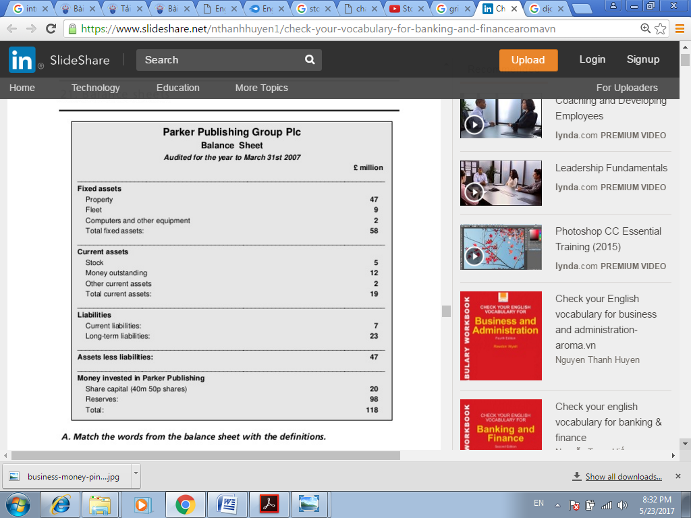

|  |  |
| --- | --- |
| 1. property | 1. things that will be turning into cash within one year |
| 1. current assets | 1. an amount of money reserved for long-term capital investment projects or other large and anticipated expenses that will be incurred in the future |
| 1. stock or inventory | 1. money deposited in bank accounts |
| 1. outstanding | 1. lands, buildings and parts of buildings |
| 1. curent liabilities | 1. money which must be paid out within one year |
| 1. long-term liabilities | 1. money which must be paid out after one year |
| 1. share capital | 1. goods not yet sold |
| 1. reserves | 1. money raised by issuing shares in the company |

**B. Write the words into the spaces**

|  |  |  |  |
| --- | --- | --- | --- |
| cash flow | founded | liabilities | outstanding |
| sale or return | subsidiary | trading | went public |

Parker Publishing was **9**___________ in 1872 by Hieronymomus Parker, originally as the publisher of a religious periodical called *The Preacher*. It now specialises in lifestyle magazines, and, through its **10**_________ Tekpress, also publishes everal highly successful periodicals on consumer interest subjects such as computing and hi-fi. The distribution arm also distributes magazines from other publishers, and has become highly profitable in its own right.

The company **11**_________ in 1987. The shares, originally priced at 50p, are **12**__________ at the time of writing for around £3.20.

Like many magazine publishers, Parker are vulnerable to **13**__________ problems. As their magazines are on **14**_________, they usually have millions of pounds **15**________ from retailers, and have **16**________ of several million more in printers’ bills. In addition they have to keep large sums of money tied up in stock – the firm’s warehouses in London and Manchester usually contain aroung five million pounds’ worth of magazines.

** END OF THE TEST **

**PART 1.**

1. payee
2. logo
3. amount in words
4. amount in figures
5. account number
6. signature

**PART 2.**

1. registers
2. retail
3. entered
4. touch
5. receipt
6. read
7. transfer
8. by
9. sign
10. identification
11. secure
12. signature
13. transaction
14. verified

**PART 3.**

1. Credit ratings
2. Default
3. debt
4. Mortgage
5. financial institution
6. pension funds
7. mutual funds
8. securities
9. investor
10. bankrupt
11. False
12. False
13. True
14. True

**PART 4**

1. E
2. G
3. H
4. C
5. A
6. D
7. F
8. B
9. False. Turnover is total income
10. False. Others were depreciation of fixed assets and selling and marketing cost.
11. False. The reduction was very small percentage
12. True. Nearly a quarter of their total expenses
13. True. The profit from sale of fixed assets was £6m
14. False. Less than half went to the shareholders.
15. False. Dividends were 17.4p per share
16. False. They made a healthy profit

**PART 1.**

1. payee
2. logo
3. amount in words
4. amount in figures
5. account number
6. signature

**PART 2.**

1. rates
2. low
3. branches
4. high street
5. make withdrawals
6. cash dispensers
7. cheque book
8. debit card
9. current
10. statements
11. make
12. switching
13. range
14. puts

**PART 3.**

1. overdraft
2. interest rate
3. financial institutions
4. inflation
5. earnings
6. bills
7. mortgage
8. boost
9. strike
10. stock market
11. False
12. True
13. False
14. True

**PART 4**

1. D
2. A
3. G
4. C
5. E
6. F
7. H
8. B
9. founded
10. subsidiary
11. went public
12. trading
13. cash flow
14. sale or return
15. outstanding
16. liabilities